Simulation Results and Discussion

* Comparison of Epstein Model with our Model
  + Free Assembly Catalyzes Rebellious Outbursts
  + Salami Tactics of Corruption
    - Linear decrease
    - Sudden drop
* Influence of cop distribution
  + View 1-3
  + View 3-5
  + View 5-7
* Problems
  + View
  + Movement

Free Assembly Catalyzes Rebellious Outburst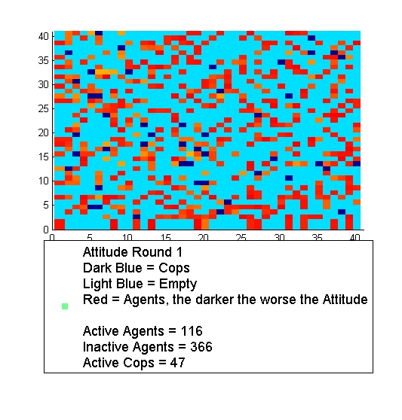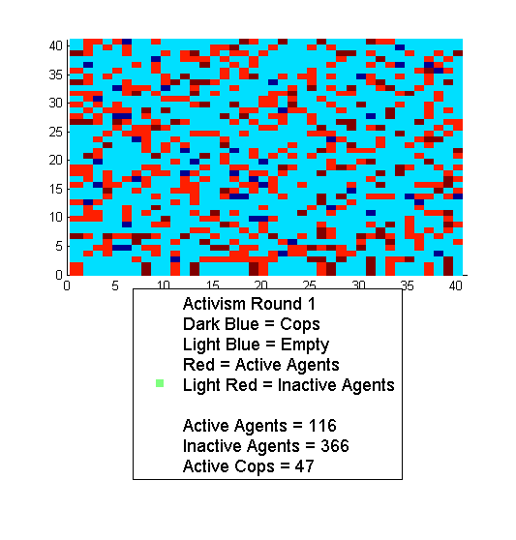

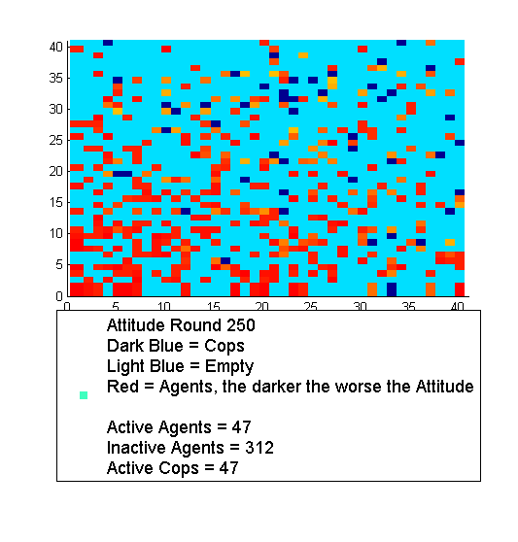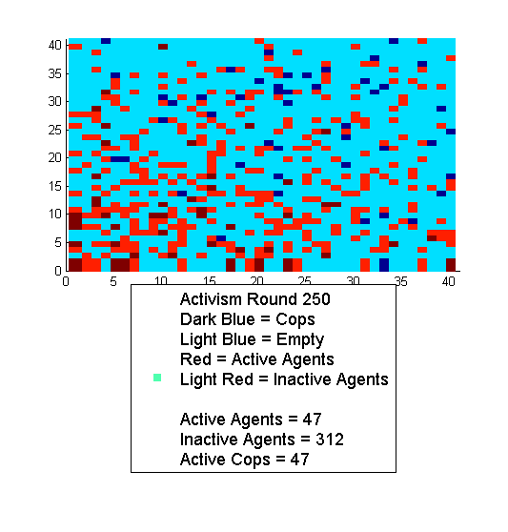

As in the Epstein model it can happen that the local cop to agent ratio drops too low and agents turn active. Later when the cops return the active agents disappear again either by arresting or turning inactive. A good example for that is round 250. Since there are no cops in one corner agents turn active. The simulation was done with the following input:

L = 0.7;

O_to_U_Ratio = 0.5;

C_to_A_Ratio = 0.1;

Jailterm_Min = 3;

Jailterm_Max = 5;

Activism_Threshold = 0.1;

Vision_Min_Cops = 5;

Vision_Max_Cops =7;

Vision_Min_Agent = 5;

Vision_Max_Agent = 7;

All the other variables have been set to 0.

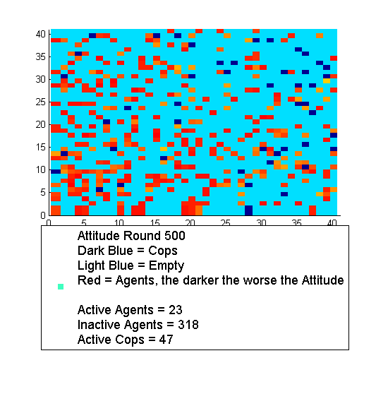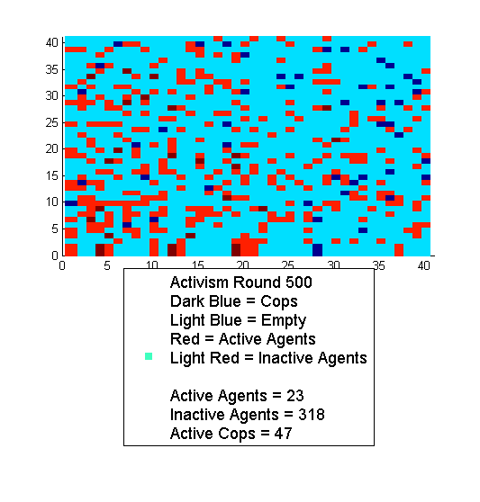

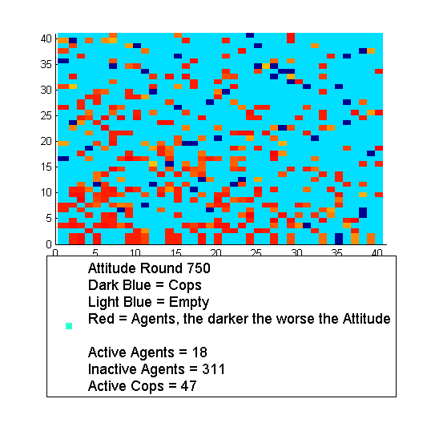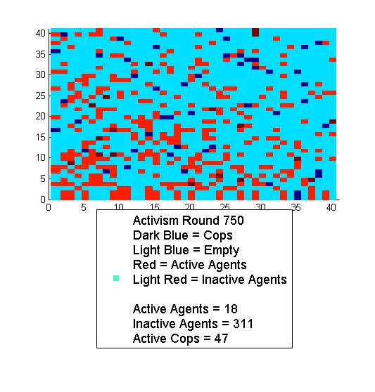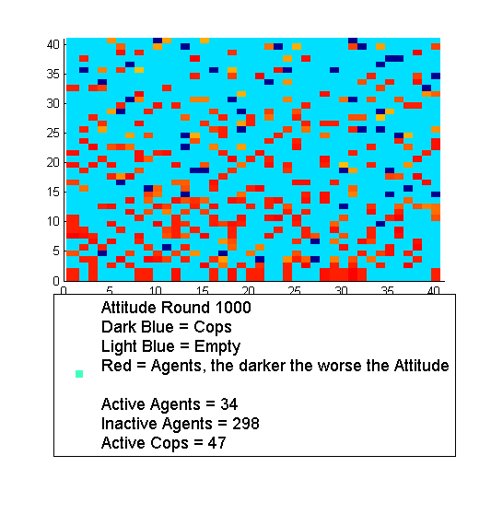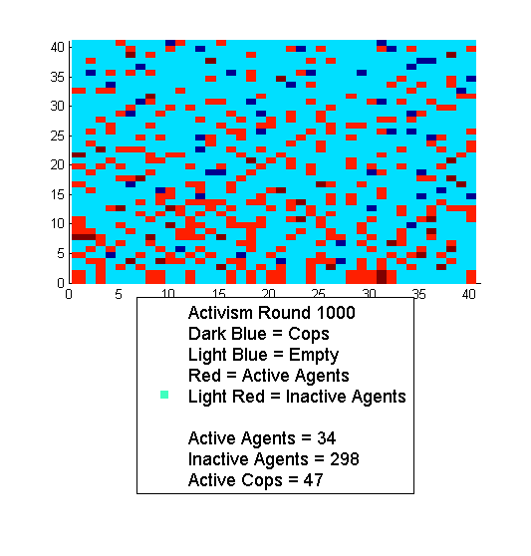

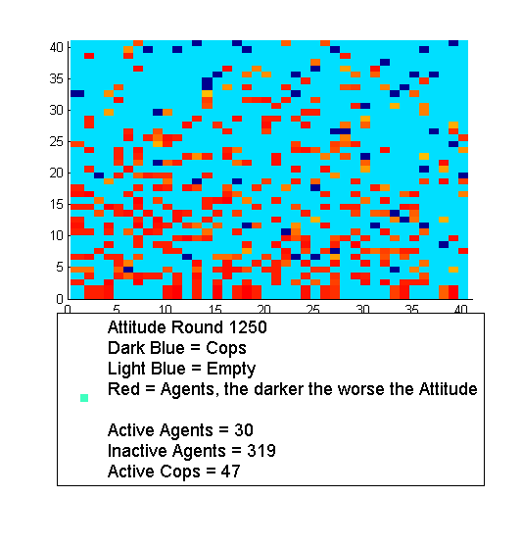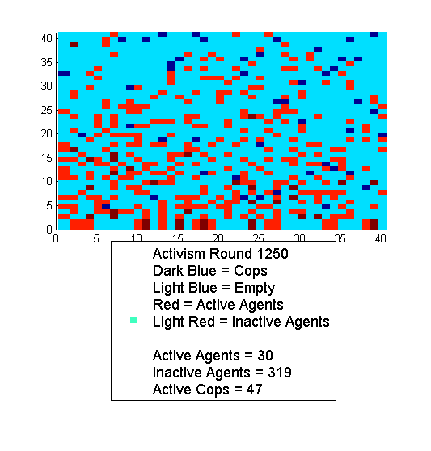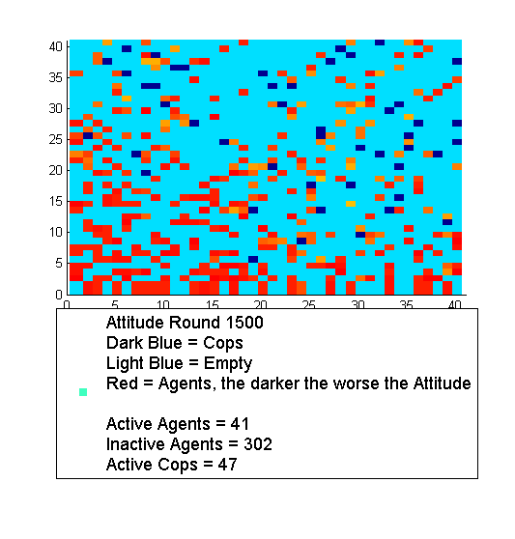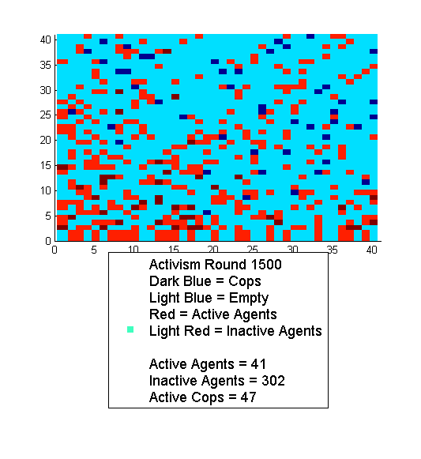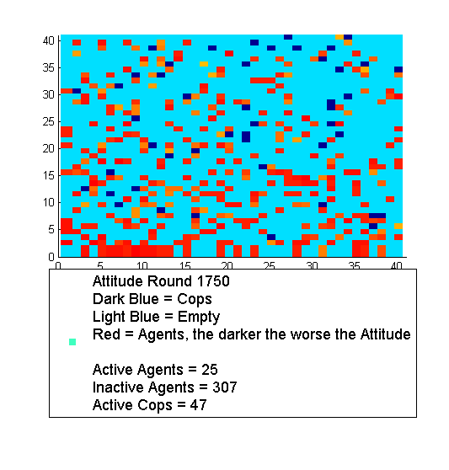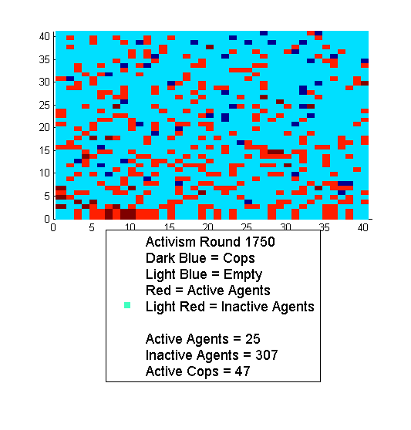

In the next graph we plot the number of active agents in every round. There is a sudden drop in the first couple of rounds: In the first round there are 116 active agents. But later the number of active agents is never larger than 60. Also can be observed that the number of active agents and the number of imprisoned agents affect each other. If the number of active agents is high the number of prisoner will probably be low and if only a few agents are active the prisoner will probably be full and vice versa.

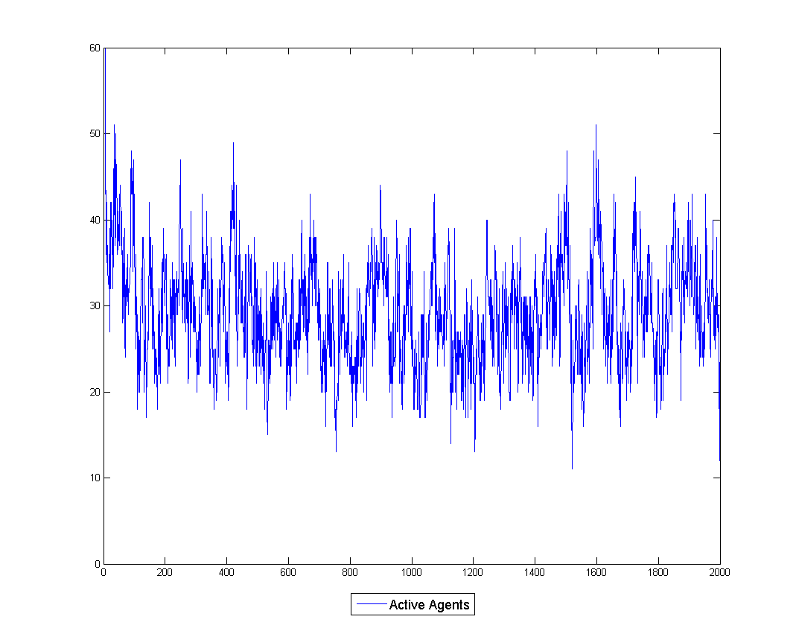

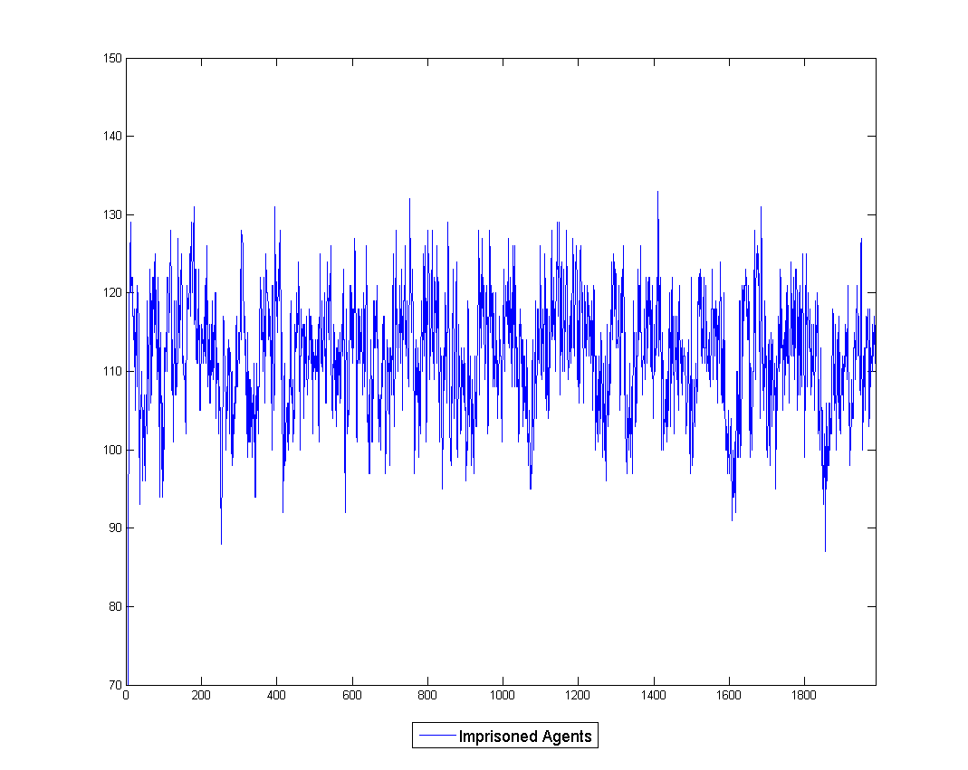

Salami Tactics of Corruption

As in the Epstein model we studied the influence of a Change in legitimacy. We looked at two cases: A sudden drop in legitimacy and a smoothly decay in legitimacy. Booth cases happened in the real world. A very good example for a sudden legitimacy drop is Greece. After a protester was shot during a demonstration the public opinion suddenly dropped and the demonstration became even bigger. An example of a smoothly decay is Egypt. The system seemed to by quiet stable but the lack of a better future for a whole generation steadily decreased the legitimacy.

Sudden drop

We started with a legitimacy of 0.9. Than in round 10 we reduced the legitimacy by -0.3. This leads to a sudden increase of the number of active agents. Since the central force is very strong (number of Cop/agents =0.2) the number of active agents declines again and the prison gets full.

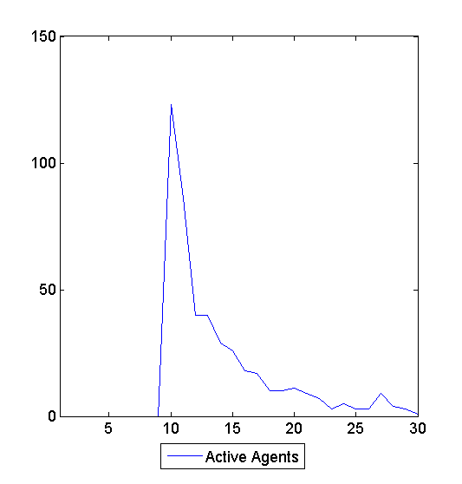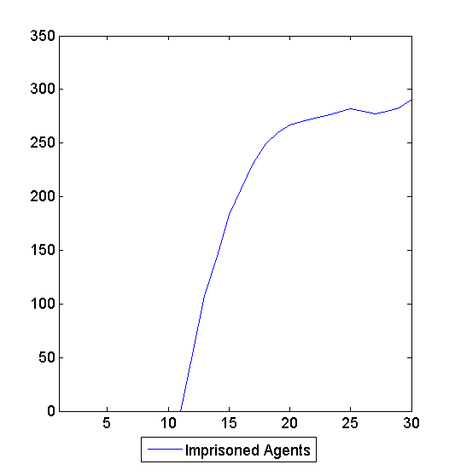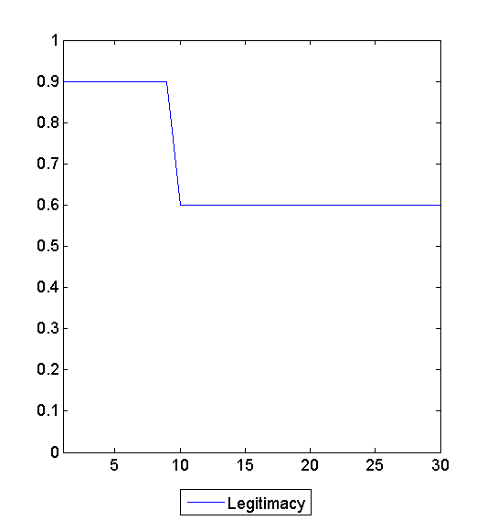

L=0.9, O_to_U_ratio=0.5, C_to_A_Ratio=0.2, Jailterm =(8,25), Activism_Treshold=0.1, Vision=7

Linear decrease

In this case all the parameters are exactly the same as above. The only difference is the Legitimacy. Instead of a sudden drop we reduced the legitimacy round by -0.6/200. In this case we don’t observe a peak in the number of active agents. Since the central force is strong and the prison terms rather long the cops can handle the situation.

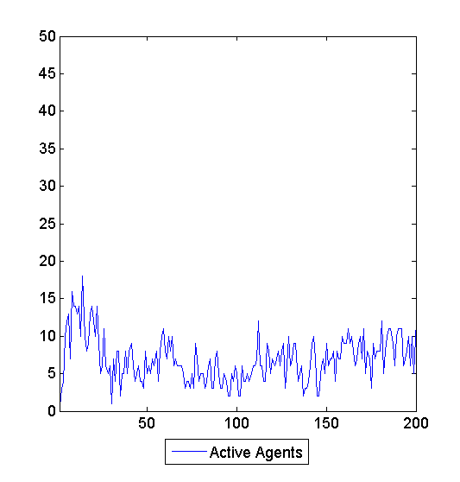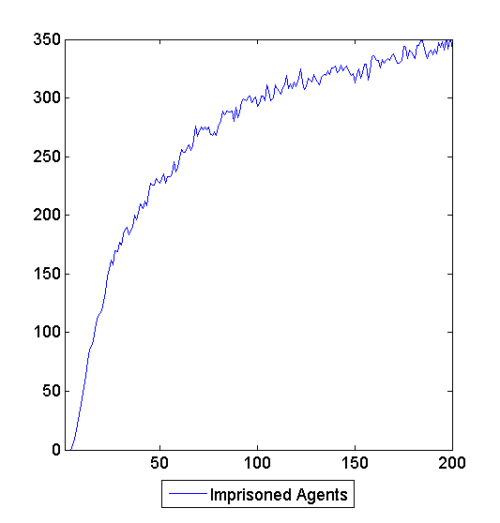

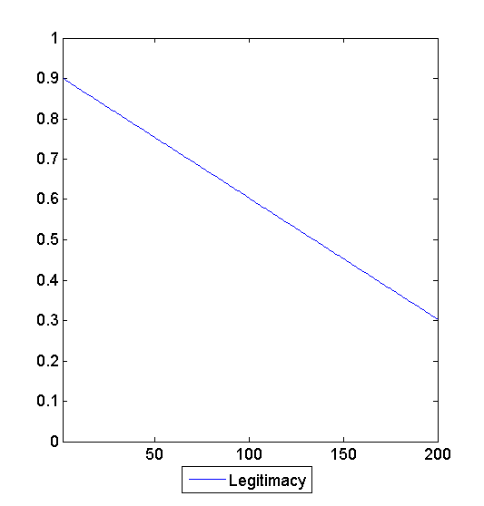

L=0.9, O_to_U_ratio=0.5, C_to_A_Ratio=0.2, Jailterm = (8, 25), Activism_Treshold=0.1, Vision=7

Influence of Cop Distribution

We wondered what would change if we would let star the cop in the middle instead of randomly distributed and how does the influence of the starting position of the cops depends on their view.

The idea is the following: In the beginning 49 cops are stationed in the middle of the field. Then they spread out and suppress the demonstrations. The question is now: How many rounds does it takes until the cops starting in the middle are as successful as the ones starting randomly.

The following plot shows the field in the first round and in the 100 round.

Centre

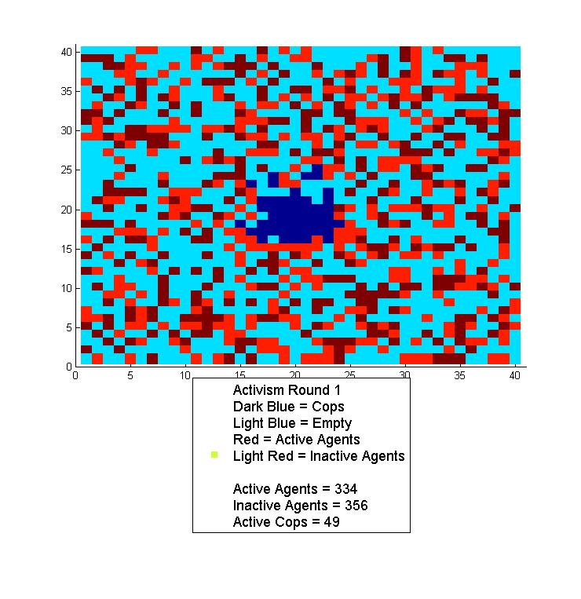

Randomly

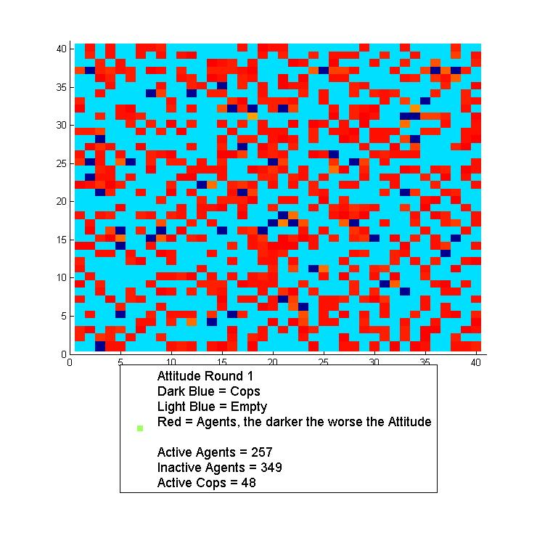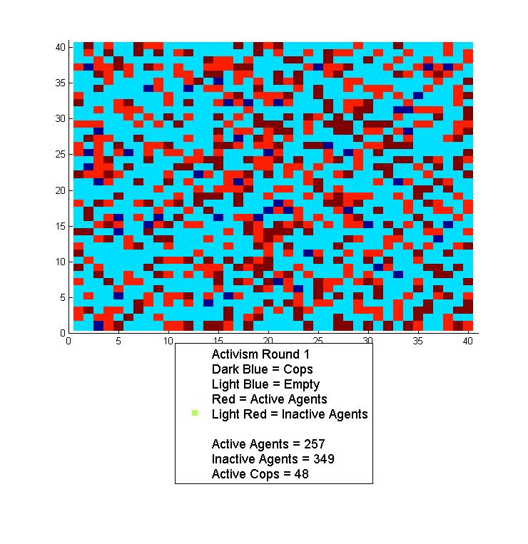

Centre

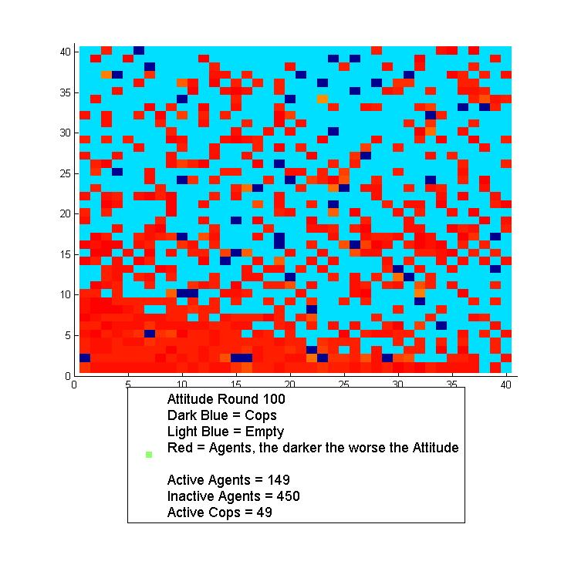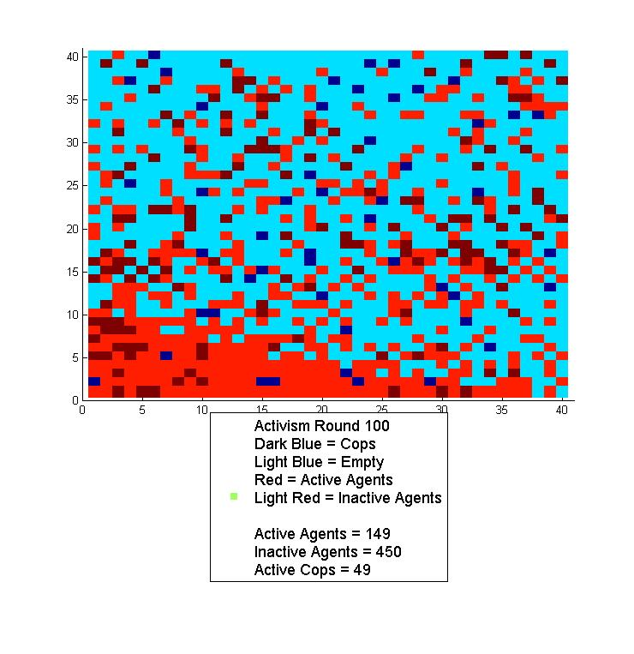

Randomly

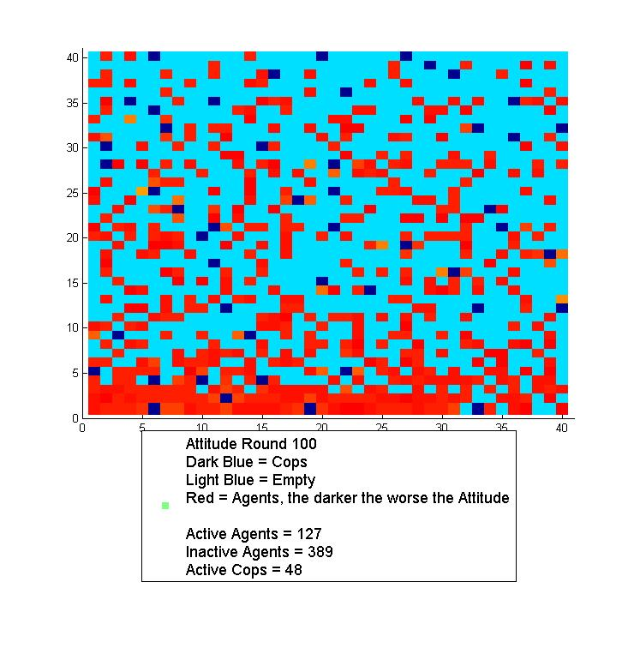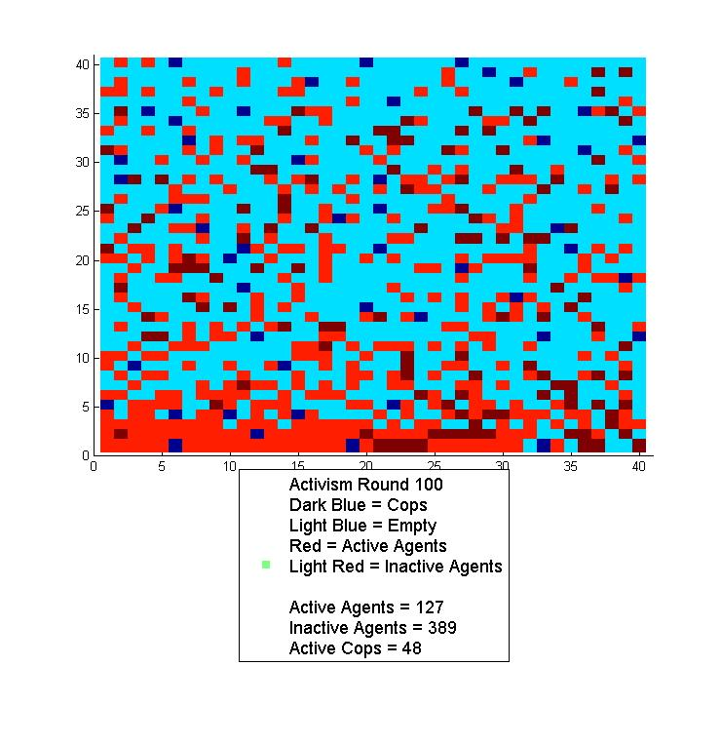

There's clearly a big difference in the first round, but after 100 rounds the plots looks alike.

WE run the simulation with the following parameters:

L=0.8, O_to_U_Ratio =0.7, Jail = (3,6), Activism_threshold=0.1, Vision = (1,3)

In the case of randomly distributed cops we set the C_to_A_Ratio to 0.0743. So expected value of cops is 49 as in the case of cops starting in the centre.

In the following two graphs we clearly see that the cops starting in the middle are less successful in suppressing active agents and filling up the prison.

Centre

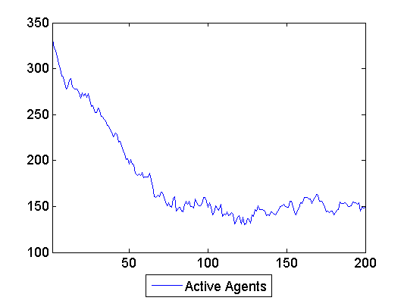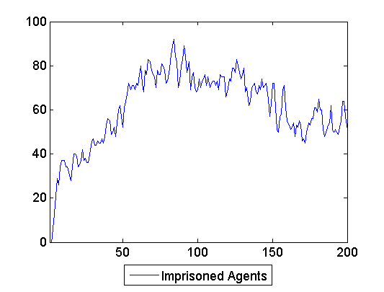

Randomly

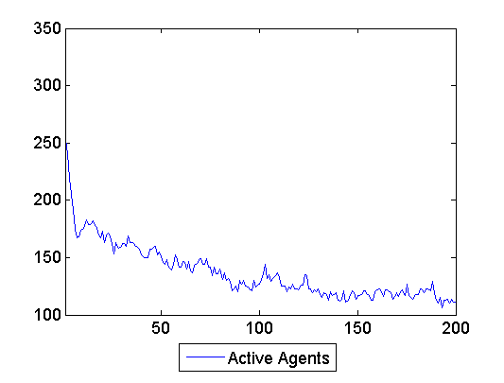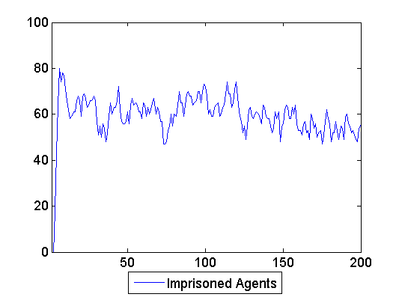

To get a more accurate result we took the mean and standard deviation of the number of active agents and the number of active agents over 30 runs of the simulations. We did that for 3 different tips of view ranges:

View randomly distributed in (1,3)

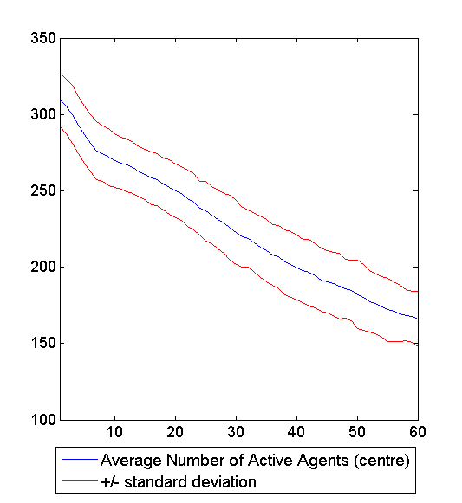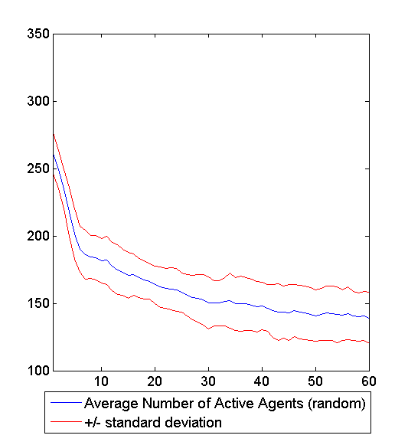

After 60 rounds the cops starting in the middle are still clearly less successful in suppressing active agents than randomly distributed cops. Also the shapes of the curves doesn’t look alike

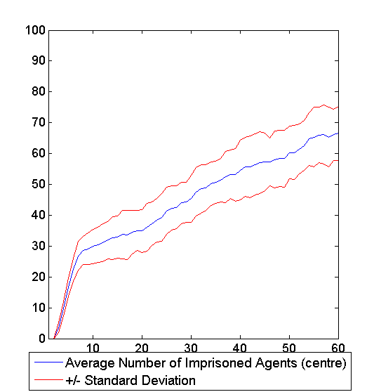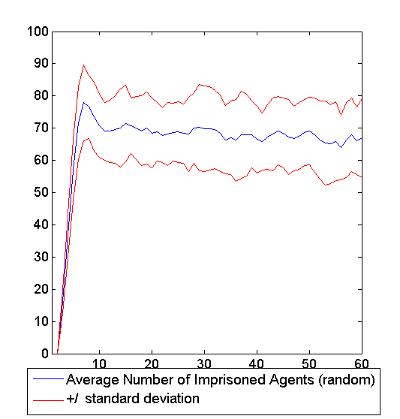

The cops on the middle need 60 rounds until they finally have imprisoned as many agents as the randomly distributed cops.

View randomly distributed in (3-5)

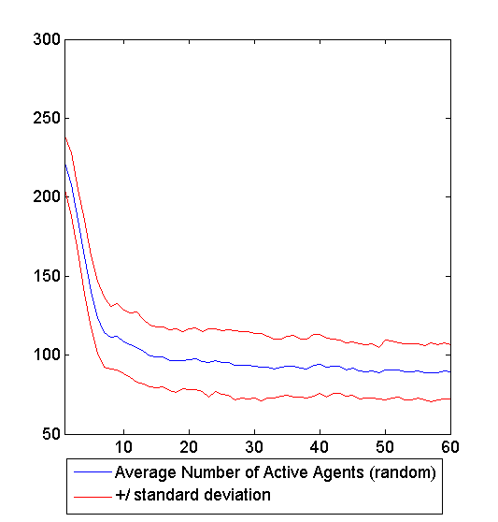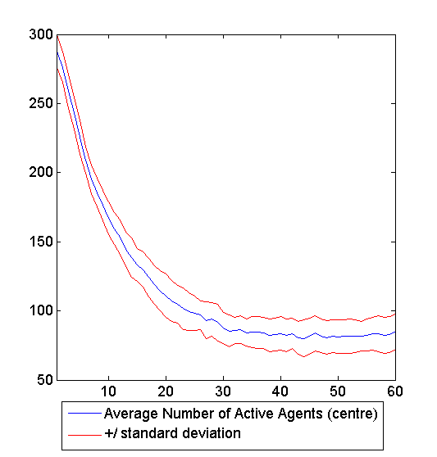

In this case it takes the cops starting in the middle about 25 rounds to get as successful in suppressing the active agents as the randomly distributed cops.

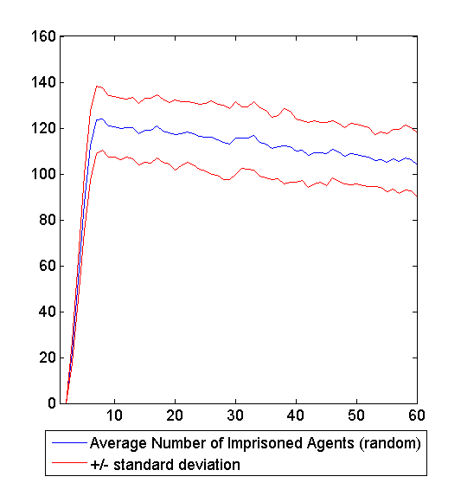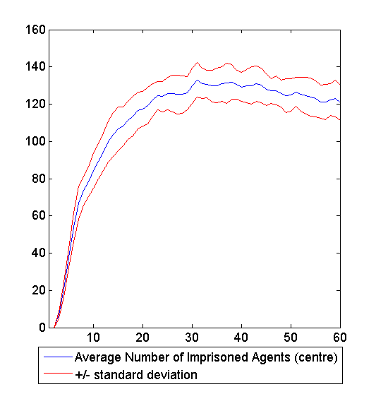

The curve in the random case after round 5 looks like the curve in the centre case after round 30. This holds also for the graph of active agents.

View 5-7

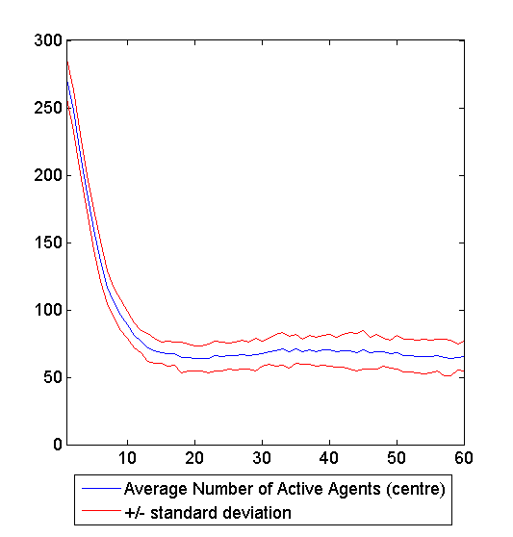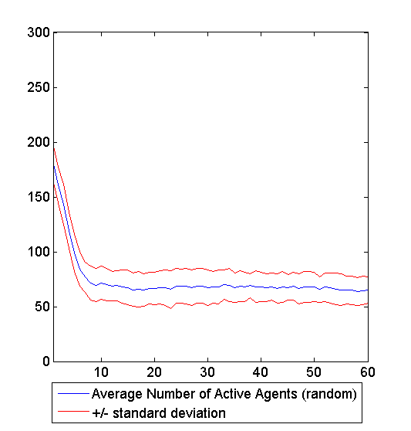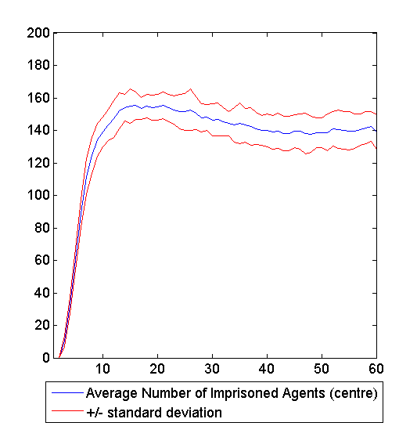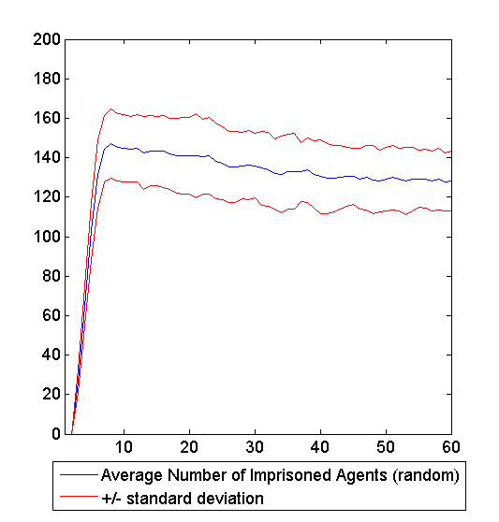

In this case the curves in the centre case shifted by about 5 rounds to the right looks like the curves in the random case. If we would increase the view even more the difference between the two cases would disappear completely. This is clear since we have only a 40* 40 field. So after about 4 moves of length 10 a cop starting in the middle can reach every position in the field.

It is also very interesting how the whole system behaves: After a number of rounds depending on view, population density and cop density the average of the simulations gets constant.

Problems

Not for all input variables the outcome of the simulation is reasonably.

View

We get a problem with our simulation if the view is very low and in the same time the population density is high. An Example for that are the plots of the field in the chapter *Influence of Cop Distribution.*

There we have a view in (1,3) and a ratio of 0.7 of occupied to unoccupied fields. After 100 rounds the people aren’t randomly distributed anymore. They sort of glue together in the corner. Since the view is small most of the people in this accumulation can’t move at all.

Movement

Our agents and cops can only move left, right, up and down. This seems to be not very realistic. If only one cop is in a particular region the situation can be very unrealistic. But if many agents are in a particular area they can cover the whole area with their movement and the situation is similar to the case there the cops can move in all directions. So always place enough cops in the field. The same also holds for agents. Enough means at least more than 40.